**Executive Summary**

Electric vehicles (EVs) are viewed as an answer to a variety of difficulties in the UK, the US, and a few other nations, including decreasing greenhouse gas emissions, sustaining economic development, improving air quality, and reducing fossil fuel imports. Yet, the shift from a fossil-fuel-based transportation system to an electric mobility system is fraught with difficulties. One of the most significant impediments is EVs' substantial price disadvantage when compared to traditional internal combustion engine automobiles. The battery is the costliest component of an electric vehicle, accounting for half of its total cost; hence, the feasibility of EVs is directly tied to the pricing of a battery. This study details the cost estimation for electric cars utilising SEER Hardware. Based on the estimates we obtained using SEER, we will discuss a few cost-cutting measures.

TABLE OF CONTENTS

1. INTRODUCTION………………………………………………………………………………08

1.1 Why Electrical Car Still Expensive………………………………………..................10

1.1.1 Factor Affecting the Cost of Electrical Vehicle Development……….......11

1.2 Major Cost Component of Electric Vehicle Battery………………….......................12

1.3 Current State of EV battery……………………. …..………………………………...12

1.4 Battery Development...…………………………………………………........................12

1.4.1 Component of Electric Vehicle Battery……………………………….........13

1.5 Performance of Battery………………………………………………...........................15

2. Cost Drivers for Electric Car Development, production and disposal.......................................16

2.1 Life Cycle Cost Analysis..................................................................................................16

2.1.1 LCC model development.................................................................................17

2.1.2 Consumer LCC model....................................................................................17

2.2 Acquisition Phase.............................................................................................................18

2.3 Operation Phase................................................................................................................18

2.4 Disposal Phase...................................................................................................................20

3. Cost Estimation Using SEER for HARDWARE........................................................................... 21

3.1 Introduction to SEER for HARDWARE........................................................................21

3.1.1 Key Features of SEER-H..................................................................................21

3.2 Cost Estimation of Electric Cars Using SEER-H...........................................................23

4. Exploring Cost reduction Strategies for Electric Vehicles...........................................................28

4.1 Cost Reduction Strategies.................................................................................................29 5

4.1.1 Incentivizing Cell Manufacturing....................................................................30

4.1.2 Development of ancillary Industries................................................................30

4.1.3 Incentivizing reverse logistics, reuse for stationary usage.............................30

4.1.4 Improving the Ability of Critical Cell Components.......................................31

4.1.5 Standardization.................................................................................................31

4.1.6 Battery as a Service..........................................................................................31

4.1.7 Demand Aggregation.......................................................................................31

4.1.8 Dedicated Battery research institute..............................................................31

4.2 Ranking of Strategies and Recommendations................................................................32

4.3 Authentic Data to Validate the Cost Models.................................................................

5. Comparison of Cost analysis and strategy of UK with US.........................................................

5.1 Comparison of Cost.......................................................................................................

5.2 Comparison of Strategy.................................................................................................

6. Conclusion.......................................................................................................................................

7. References........................................................................................................................................

**LIST OF FIGURES**

Figure 1: Policies for Electric Vehicles...............................................................................

Figure 2: Components of Battery......................................................................................14

Figure 3: Base case Consumer LCC framework.............................................................18

Figure 4: Weight Distribution Chart...............................................................................24

Figure 5: Quick Estimate...................................................................................................25

Figure 6: Detail Estimate....................................................................................................26

Figure 7: Production Quantity...........................................................................................26

Figure 8: Life cycle Cost allocation Chart.........................................................................27

Figure 9: Unit Production Cost Comparison Chart..........................................................27

Figure 10: Final Cost.............................................................................................................29

**LIST OF TABLES**

**Table 1: Work elements & Parameters Inserted in SEER.................................**

**Table 2: Components & their Weights.......................................................................**

**Table 3: Strategies & Policy Area............................................................................**

**Table 4: Strategies priority Table.........................................................................**

**Table 5(a): UK vs US cost comparison.....................................................................**

**Table 5(b): UK vs US Strategy Comparison........................................................**

**1. INTRODUCTION**

Transportation-related greenhouse gas emissions are among the highest in the world. The decarbonization of the transportation sector has become a crucial component of the worldwide climate change mitigation plans to restrict global warming to 1.5 degrees Celsius over preindustrial levels. Electric vehicles (EVs) and other cleaner modes of transportation are now widely acknowledged as being crucial to reducing the number of greenhouse gases released into the earth's atmosphere. Because of this, electric vehicles haven't become popular among the general public. As batteries are the most expensive part of electric cars, lowering their price will help remove the financial barrier preventing their broad adoption. The main goal of this study, which considers many strategies, is to lower the price of electric vehicle (EV) batteries.

In terms of carbon dioxide emissions in 2017, the transportation sector led all other industries with almost 8 Gt of CO2. Three-quarters of the emissions from the transportation sector were produced by private and commercial road traffic. This demonstrates how much carbon dioxide emissions can be cut by switching to electric transportation. E-mobility includes pure EVs, REEVs, and hybrid EVs, among other vehicles.

Governments must provide transportation services while simultaneously reducing greenhouse gas emissions as cities become more densely inhabited, particularly in emerging nations with big populations. As a result, to eliminate obstacles to the widespread adoption of e-mobility and to reconstruct the transportation system, it is essential to design regulations that are both financially and ecologically sustainable. One of the main barriers to the adoption of EVs is the high total cost of ownership, which policymakers are still attempting to address in the context of evolving technology and a burgeoning EV industry.

Due to the extensive availability of refuelling infrastructure, electric vehicles (EVs) compete with traditional internal combustion engine (ICE) cars since they are now more affordable and convenient to refill. Traditional cars often provide their owners with high performance and financial efficiency. There are ongoing efforts to improve the efficiency and reduce the price of EVs, including the construction of charging infrastructure and the offering of financial incentives for R&D, production, and adoption. The majority of these initiatives concentrate on the batteries, which make up more than half of an EV's cost (Kochhan, et al., 2014). To promote the usage of electric vehicles in the US, a cheaper battery will be crucial.

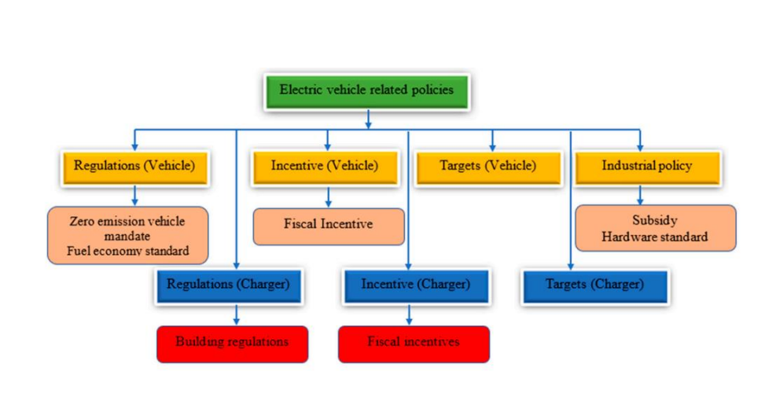

**Figure 1: Policies for Electric Vehicle**

Fast-growing United States has set lofty targets for reducing climate change. The development and adoption of electric mobility across all segments, including private vehicles, public transportation, railroads, mass transit, and freight, must be accelerated by the transportation industry if we are to meet the demands of a growing population while also reducing greenhouse gas emissions. In the US, the car sector has grown significantly.

Automobiles may be manufactured at a reasonable cost for both the domestic and international markets because of the number of qualified workers and the regional ecosystem supporting the fabrication of automotive components. But, switching to electric transportation will require greater government aid. One area that needs immediate attention is battery manufacture since a quicker transition to electric mobility depends on reduced battery costs. The switch to electric mobility is a crucial component of the transition to more sustainable socio-technical systems from old and widely used ones. Thus, market systems and institutions will need to be able to adapt to the quick rate of technological progress to assure their success (Lehmann, 2010; Twomey, 2012; Weber & Rohracher, 2012).

* 1. **Discuss the reasons why electric cars in the market are still expensive.**

Electric cars are made feasible by batteries. The biggest and most vital part of an EV is its battery. Battery costs are high. EVs are hence pricey. It's challenging to question this kind of thinking.

EVs have higher R&D expenses than conventional cars, which are upgraded annually but seldom undergo total redesign expenses are included in vehicle prices, and since each manufacturer produces fewer EVs than conventional cars, higher R&D expenses are spread out among fewer cars.

Car costs increase when there are fewer rivals on the market. Prices should fall as more manufacturers enter the market and start producing EVs. Although it's exciting to learn that something that was tested decades ago still holds for products in everyday life, it's annoying that a portion of the cost of an EV is determined by market forces rather than actual costs.

Regular automobiles are less expensive for manufacturers to produce than EVs since they are produced at a higher volume. EVs' greater production costs are reflected in their increased price tags. Some buyers of EVs consider them to be luxury goods or status symbols and wish to spend more on them than they would on a typical car.

Compared to the batteries used in normal automobiles and hybrid vehicles, lithium-ion batteries are substantially more expensive to produce and use in electric vehicles. Lithium batteries are still overpriced in comparison to other batteries, despite a sharp decline in price over the past 12 years when the Nissan Leaf and Chevrolet Volt were first released.

Around the nation, EV insurance is more costly than regular auto insurance. This is because EV servicing and equipment are more expensive than those traditional vehicles. With an EV, replacing the battery alone can cost up to $15,000. It's vital to search around for the best auto insurance for whatever vehicle you drive, but shopping around and obtaining quotes from many insurers is even more critical for securing coverage for an electric vehicle (EV) because costs vary more and are more expensive overall.

Because electricity is so much less expensive than petrol, the real expenses to operate an EV are lower than those to operate a conventional car. Yet, the time and effort required to maintain an EV charged and ready to go may be considerable, and those are mostly unrecognised expenditures. Most individuals don't factor in time, effort, and logistics when creating their budgets. At a Level 1 home charging station, charging an EV can take up to 40 hours (the default charging cord shipped with the vehicle). If a customer is even close enough to a public charging station to make it worthwhile to use one, charging a car in half an hour there may take some forethought.

These elements all work together to raise the price of electric vehicle expenditures.

**Factors Affecting the Cost of Electrical Vehicle Development**

Apart from the battery, an electric automobile is more expensive. For a variety of reasons, electric vehicles are more costly than those with conventional engines. These problems make battery-powered vehicles more expensive.

• Automakers must invest a lot of time and money into the development of electric vehicles. To fit a specific electric vehicle, everything from the battery pack to the wheels must be customised.

• The electric vehicle's working mechanism may be straightforward in comparison to the working mechanism of a conventional automobile, forcing automakers to boost their prices to meet the extra expenses of production. Unfortunately, constructing an electric vehicle needs a lot of sophisticated and high-tech equipment.

Electric motors, high-capacity batteries, and other gadgets all require complex electrical systems.Some battery-electric vehicles also include cutting-edge driver-aid technologies. As a result, BEVs are more costly than regular cars.

• Because electric cars are still in the early phases of research, there aren't enough experts in the industry. As a result, it is difficult to find the trained labourers needed to construct these automobiles. This has an impact on the total price of a battery-powered automobile. Due to a lack of skilled mechanics, owning an eco-friendly vehicle becomes unaffordable.

• How much does auto insurance cost? because an electric car has a high monetary value. Car insurance is also very expensive. Due to this, the price of insurance for an electric car is more than it is for a gasoline or diesel vehicle.

Battery-powered vehicles have a large number of electrical components, so you might need to add to the stock of accessories in your automobile. As a result, the cost may significantly increase. When the price of batteries decreases, expect insurance costs to decrease as well.

However, by purchasing insurance online from digital-first insurers like ACKO, you can save money on premiums by avoiding agent commissions and other processing costs. With ACKO, you can ensure your electric vehicle quickly and easily without having to complete a drawn-out application.

**Major Cost Component of Electric Vehicle Battery**

Finding the main cost factors and concentrating on them and their potential role in reducing the cost of the battery are the objectives of dissecting its cost.

The demand for a certain application (two wheels or three wheels; vehicles or buses) will alter the overall battery demand and, consequently, the advantages of mass production. By altering the values of pertinent parameters and inputs in line with the US environment, the Excel-based application BatPac was used to create this information about the performance and cost of an electric car battery.

**Current Status of the EV battery value**

The first question, which is purely theoretical, only discusses battery manufacturing. Cost-cutting strategies may exist beyond manufacturing, and the model's adoption will rely on the readiness of other industries. participants in the production and packaging of batteries. As a result of these problems, a value chain for EV batteries in the US was created, and players in the industry were consulted. the specifics of the company's tactics and actions for cost-cutting. At this time, a select group of interested parties is also gathered.

**Battery development**

The fundamental electrochemical units are the battery's cells. When talking about battery chemistry and characteristics, it's usual to use both the terms "battery chemistry" and "cell characteristics" interchangeably. A game-changer for electric vehicles (EVs), the lithium-ion (hence referred to as Li-ion) battery allowed them to for the first time compete with conventional vehicles on price and performance. Li-ion batteries represent a significant advancement over earlier batteries in terms of rechargeability, energy density and power output, durability, and cost. A review of the properties of Li-ion batteries and their advantages over other existing EV battery technologies is offered here.

**Component of Electric Vehicle Battery**

The four main parts of a Li-ion battery are the cathode, anode, electrolyte, and separator.

**Anode**

Most lithium-ion batteries employ graphite as their anode material. A durable, affordable, lightweight, and porous anode material, graphite may be created artificially or organically.

**Cathode**

Li-ion batteries produce power via an electron flow in the external circuit brought on by chemical reactions taking place inside the battery cell. The entity that absorbs electrons becomes negative, just like any chemical reaction, whereas the entity that releases electrons becomes positive. The cathode, or positive electrode, of a lithium-ion battery, is composed of lithium as a positive material. On the other hand, because lithium is unstable in its elemental state, the cathode is made of a lithium compound. The features of the cathode play a significant role in cell capacity and electrode potential differential.

**Electrolyte**

Externally, electrons go between the cathode and anode, whereas ions migrate within a cell to counterbalance this movement. The electrolyte facilitates this process by serving as an ion exchange pathway. In a lithium-ion battery, the electrolyte is a lithium salt, such as LiPF6 (Lithium hexafluorophosphate).

**Separator**

The electrodes are shielded from short-circuiting by a separator. Depending on cell chemistry, several insulating materials including polyethene, polypropylene and ceramics could be utilised. To assist the chemical reaction, the material must be able to convey the ions essential for the reaction.

An anode is a reducing electrode that gives electrons to the external circuit by chemical reaction (positive substance) (positive material). Anode is oxidised during discharge as opposed to the cathode, which is the oxidising electrode and is reduced when it absorbs electrons from the external circuit (negative material). The procedure is completely the reverse while charging. This is why technological research and development is focused on producing a cathode-anode combination with enhanced voltage and energy capacity while also being lighter and more stable.

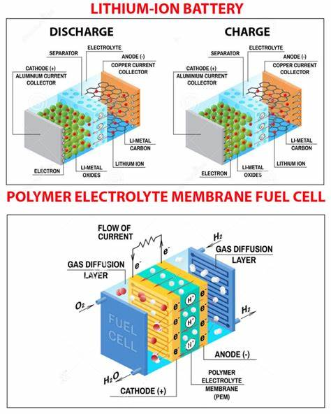

**Figure 2: Component of Battery**

When charging, an electrochemical process takes place within the cell, which is illustrated in the diagram below. There are two methods in which a battery can be discharged: through a load (such as the electric motor in a car) or through the electrolyte, in which both processes take place (a motor) (a motor). To assist the transport of electrons, both electrodes are coated with an active binder component. A cell's characteristics are impacted by the materials employed for its electrodes and electrolytes. Because of this, diverse chemistries are used for varied reasons.

**Key Consideration**

The electrochemical potential of a cell's active components, which comprise the anode, cathode, and electrode, determines the cell's potential output. The potential of a cell will be inversely proportional to the relative weights of these active components. The anode potential (positive) and cathode potential (negative) are added to form the cell potential.

The oxidation potential of the anode and the reduction potential of the cathode is added to form the cell potential.

The theoretical capacity of the cell is measured in Coulombs or Ampere-hours (Ah). The kind and quantity of reactive material in the cell impact the result because of the way that cells function. The total energy stored in a cell is determined using the theoretical capacity (Ah) and cell potential (Po) (V). Hence, the product's unit of measurement is the Watthour (Wh). On the other hand, cellular energy and capacity are far lower than they should be since the cell also has a sizable number of inactive components that are crucial for its function (Figure 2-3). These nonactive components diminish the relative weight of the active materials in the cell.

**Performance of Battery**

Theoretical and actual energy outputs of the battery system vary. Theoretically, the theoretical limitations of various batteries vary. Yet, factors that influence battery performance must be taken into consideration. When utilised under poor circumstances, batteries exhibit surprising behaviours. Here, we'll discuss several additional factors that might decrease a battery's performance or limit its lifespan (such as voltage drop, energy density loss, etc.).

The architecture of the battery and the design of the individual cells have a significant impact on a battery's performance. An intrinsic trade-off exists in electrode design at the level of the individual cell between the discharge rate and the electrical capacity of the cell. In search for the ideal electrode design for a given application, a huge number of experiments are carried out. Batteries with two electrodes are sometimes needed for certain applications to optimise capacity and discharge rate, which increases the battery's total cost.

How batteries are charged has an impact on their lifespan as well. Unbalanced cell performance inside a battery has an impact on voltage, capacity, and discharge rate. Smarter enhanced algorithm solutions have recently been developed to control cell fluctuations and are used in battery state-of-charge monitors (Beard, 2019). The capacity, voltage, and charge characteristics of a cell can all be significantly affected by altering its internal resistance. A battery pack may have similar cells, but depending on where a cell is positioned, its physical characteristics might differ. Thermal control for battery-powered EVs is crucial. A temperature increase that exceeds a particular threshold impairs the performance of cells and may even be harmful to the experimenter's health. Research on battery heat management in hotter areas, such as those prevalent in the US, is lacking. Several cooling solutions prevalent in cooler countries aren't viable due to the country's excessive heat in some parts.

As a result of these variables, a battery's lifespan is likewise decreased. More study in this area is required with a larger emphasis on US climatic conditions.

1. **Cost drivers for electric car development, production, operation, and disposal**

**Life Cycle Cost Analysis**

A more precise cost-benefit analysis is possible when considering the total cost of ownership over the length of an asset's useful life, or "lifecycle cost." The "realistic appraisal" produced by LCC analysis is strengthened by taking time worth of money into the account. Finding expensive parts of a product's lifecycle and comparing it to competing products are two helpful applications of product lifetime cost analysis. The LCC procedure is based on AS/NZS 4536:1999 Standard, which lists six stages in the LCC process: analysis plan, model development, model analysis, analysis documentation, findings review, and implementation & update (implementation and update).

The LCC is as follows for a electrical car:

**Total LCC = Acquisition cost + Sum (Operating Cost for a given year + Scheduled maintenance cost+ Unscheduled maintenance cost + Car disposal cost**

For car lifecycle analyses, the United Kingdom used these cost variables. However, a lot of other studies, like this one, did not include the "Unscheduled Maintenance Cost" category due to the limited access to first-hand information, which limits the accuracy of time and cost forecasting. Therefore, this paper's study excludes unscheduled auto maintenance.

The most important factor in today's high price of electric vehicles, in terms of costs, is the battery. A typical EV lithium-ion battery is expected to cost $300/kWh at the sale. For the 24 kWh battery in the Nissan Leaf, this equates to an additional A$7,200, which is a significant price increase. The price of making batteries is, however, declining as their particular energy keeps rising. As EVs gain in popularity, it is anticipated that the massive volume of battery production will further drive down the cost per unit due to rising environmental and energy concerns.

It is important to keep in mind that, aside from the assumptions and breadth of each model, these variables have a significant impact on the total cost of ownership of an EV. While some early studies suggested that electric vehicles (EVs) won't be practical in the foreseeable future, others demonstrated that they can result in significant cost savings. For instance, a study demonstrates that EV home charging and the lack of replacement or repair expenses lead to advantageous cost savings. A replacement ICEV was expected to be ready when the EV range was reached. The costs of pollution and the infrastructure for public charging, however, were not accounted for in the figures. EVs can reduce air pollution in the UK by up to 50%, according to research, if the societal expenses of pollution are taken into account when calculating an EV's life cycle cost.

**LCC model development**

One kilometre, the functional unit for this study, was travelled by a 2011 Nissan Leaf in the metropolitan area of NSW in the US. The term "cradle to grave" study refers to the idea that this evaluation technique will take into account all expenses related to the purchase, use, and disposal of the vehicle.

An estimated 200,000 miles, or roughly 20 years at a pace of 10,000 miles per year, will be covered by a 2011 Nissan Leaf. The typical age of a registered car in the US is 10, and the average annual mileage is 14,000 km [16]. The change is required because EVs are likely to last longer than ICEVs do because of their shorter range availability, lower annual mileage of 10,000km, and the likelihood of a longer lifespan when maintained properly. For some vehicles with existing owners, a new battery is anticipated to cost about A$7,300 [17]. Since the car was bought in 2014, prices have been listed in US dollars for that year. On the guidance of the NSW Department of Treasury and Finance, a 7% interest rate has been used in this analysis.

Nevertheless, due to its simplicity, this study makes the simple assumption that the energy consumption during operation is 0.137 kWh/km, even though geographic factors have a significant influence on this. The assumed losses of the solo charging technique necessitate an additional 20% of energy. The stage 2 charging process considers this.

**Consumer LCC Model**

Based on the aforementioned assumptions and scope, Fig. 1 illustrates the basic structure of the consumer LCC model for this research.

**BASE CASE CONSUMER LCC FRAMEWORK**

**Acquisition phase**

Three components make up the price of the Nissan Leaf. The Sydney postcode and base configuration was input to obtain an idea of the vehicle's MSRP. This comes to a grand sum of $42,250. The $2740 cost includes a Level 2 standalone charger that also comes with assembly and a three-year user warranty.

**Operation phase**

The average energy consumption per kilometre (0.137 kWh/km) and the charging efficiency of 20% are two methods for estimating the annual amount of electricity required to recharge an electric car. To account for the chance that customers will choose time-based tariff options, the basic case has been set to include an 80% off-peak charge and a 20% peak charge**.** According to the nearby energy supplier, off-peak electricity costs 16.522 cents per kWh while peak electricity costs 35.046 cents per kWh. In addition, the base case model anticipates an increase in energy rates of approximately 72% every five years, which is consistent with US historical averages.

After consulting with Nissan US, it has been determined that the vehicle under test will require $380 in annual maintenance. Repair expenses have not been factored into the cost estimate because there is a dearth of first-hand user data.

Due to the unpredictable nature of repairs, it was determined that it would be impossible to predict the timing of these expenses with adequate accuracy.

One of the biggest expenses associated with using electric vehicles is the cost of battery repair. The battery of a Nissan Leaf is guaranteed for eight years or 100,000 miles, whichever happens first. The 8-year term will be achieved earlier than anticipated given the model's estimated yearly mileage of 10,000 kilometres. Because the model is conservative, the battery replacement interval has been fixed at eight years.

The average energy consumption per kilometre (0.137 kWh/km) and the charging inefficiency of 20% can both be used to determine how much electricity is required to recharge an electric car annually. We put the utilisation percentages at 80% off-peak and 20% peak to take into consideration the possibility that customers might benefit from time-based tariffs. Local energy suppliers have originally set the cost of off-peak electricity at 16.522 cents per kWh and the cost of peak electricity at 35.046 cents per kWh. Power rates are anticipated to increase by nearly 72% every five years, according to the base case projection. Discussions with Nissan US have led to the conclusion that the vehicle's yearly maintenance costs are set at a fixed sum of $380. Repair costs were not included in this research because there was a lack of first-hand user information. Additionally, since repairs are frequently unexpected, it was established that it was impossible to predict when they would be incurred. The cost of replacing the battery is among the biggest expenditures related to driving an electric car. The Leaf's battery is guaranteed for a total of 8 years or 100,000 kilometres. (or 160,000 kilometres). The 8-year term will be completed earlier than predicted given the model's anticipated annual mileage of 10,000 kilometres. The model is cautious, so the battery replacement interval is fixed at 8 years. For this study, battery replacement expenses have been set at $7,700. This is based on the price of a single battery, which comes to $5147, plus the expense of an adaptor kit needed to install the new batteries in Nissan Leaf models from 2011 to 2012.

The expense of replacing the battery is fixed for the duration of the vehicle's useful life, which is a drawback of this concept. This premise has been accepted, though, because the fundamental paradigm is conservative. Lithium-ion battery costs are predicted to decline in the future, and each case will be considered in the risk analysis. The cost of a new pair of headphones must also include tyres. One of these new tires can be purchased for about $180, it was discovered. Nissan Leaf’s Owner report indicates that the typical tire life is 30,000 kilometres or roughly three years. Finally, it was Over the course of three years of car ownership, it was calculated that a set of new tires would cost $720.The final component of operating expenses is the ongoing insurance premiums. Earlier LCC analyses since the difference between EVs and ICEVs was "secondary to" their disregard for insurance costs. variance in the area and driving history". Extensive analysis revealed this belief to be false.to this phenomenon in the US. These differences in local insurance pricing and the idea that customers would to protect themselves from new technological calamities, they choose comprehensive insurance, which We extended our analysis to include the total cost of the policies from a well-known auto insurance provider. Annual Included in the price is registration ($358), CTP ($785), and comprehensive insurance ($1415).

**Disposal Phase**

Utilizing current Lithium-Ion technologies, Taxco Incorporation has estimated the price of batteries. Recycling. The price of battery recycling has decreased from US$10/kg of battery as of this writing to US$5/kg. In other words, the price of recycling a 294 kg Nissan Leaf battery module is When the user decides to sell the car, they will be required to pay A$1935 for the vehicle's US$1374 residual value disposal.

Because of the user, it has been determined that the scrap value of EVs is equal to that of ICEVs. effectively disposes of the car after it has served its purpose. A good approximation is made because the two cars' batteries and engines are not typically considered to be scrap metal. Therefore, the estimated scrap value of a conventional car is 0.3% of the car's original retail cost.

**COST ESTIMATION USING SEER HARDWARE:**

**INTRODUCTION TO SEER HARDWARE:**

System Evaluation and Estimate of Resources (SEER) is a costing tool for hardware that enables top-down parametric estimates based on historical data, analogies, or catalogues (Galorath, n.d.).

Several top businesses employ the expanding cost-estimating software SEER for hardware. Galorath Company is the owner and holder of the licence. Due to the model's ability to draw on historical data and make assumptions based on the scant available information, SEER will still produce a cost estimate even if the whole project's data is not yet accessible.

By providing a detailed preview of the total ownership cost, estimates may be prepared at various levels to study project viability upfront, optimise project costs and timetables, assess risk, and establish thorough project plans.

**Key Features of SEER-H:**

**Parametric** **Models** that calculate labour hours, material costs, and other expenses are integrated into SEER-H as parameters. These models are based on hardware properties including weight, PCB count, heritage, quantity, learning curves, and many other productivity aspects.

**Rate & Quantity** **Models** may be quickly built up for the computation of effort and cost since the fundamental variables are understood.

**Detailed reporting** that includes labour hours, labour costs, material costs, a timetable, a total, and time phases to accommodate any output needs. Options for customised reporting, data export, and PDF are provided.

**Electro-Optical Sensors**: Users may estimate the lifespan costs of complicated electro-optical sensors with a great deal more precision and detail using the electro-Optical Sensors option (SEER-EOSTM). The user-selected technological options for the components of EO sensors, such as telescopes, focal plane arrays, and coolers, as well as precise values for important technical and performance factors, such as telescope diameter and pixel count, are used to create EOS estimations.

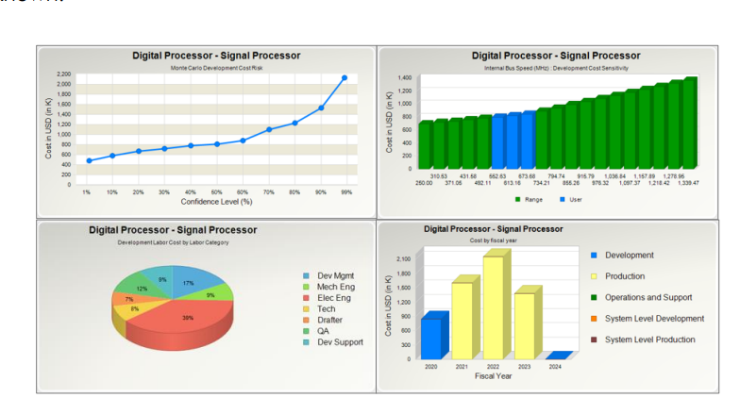

**Integrated Circuits** add-on (SEER-ICTM) makes it easier to estimate the costs associated with the development and manufacturing of bespoke ICs, ASICs, and FPGAs. Using SEER-IC, you may choose FPGA input factors like Active I/O Ports per Chip, Clock Speed or Frequency, Active Logic Cells, New Design Percentage, Front and Back-end Complexity, and more to get precise and trustworthy estimations. Process, Die Area, Feature Size (nanometres), Effective Gates per Die, Logic, Memory, IP Logic Gates and Complexity, and more than 15 more characteristics are among the input parameters used in ASICs.

**Catalogues:** Utilizing and updating standard costs, task effort, labour rates, and exchange rates are made simple by catalogues.

**Using Templates** Create accurate and consistent estimations by using the Scenarios features.

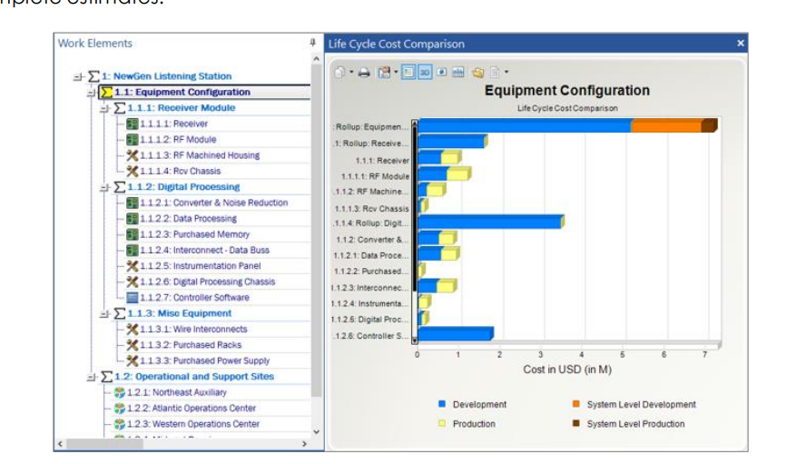

**Cost Estimation of Electric cars using SEER-H:**

With SEER-H, we can create cost estimates for any mechanical product. We must provide the estimate with a few characteristics to obtain the cost estimate. SEER makes advantage of the Kbases idea and gives inputs for parameters even before we are aware of them. Kbases has several pertinent input and adjustment ranges for a variety of circumstances.

Work components must be included to build an estimate. When constructing work elements, we must give them a description, or title, decide what type of application that element is, and set its parameters. Also, we have the option of picking many currencies as well as the nation in which we wish to build our electric vehicles.

|  |  |  |  |  |  |  |
| --- | --- | --- | --- | --- | --- | --- |
|  |  |  |  |  |  |  |
|  |  |  |  |  |  |  |
|  |  |  |  |  |  |  |
|  |  |  |  |  |  |  |
|  |  |  |  |  |  |  |
|  |  |  |  |  |  |  |
|  |  |  |  |  |  |  |
|  |  |  |  |  |  |  |